**Lab Terminal**   
 

**Submitted By :Nida Eman**

**Reg No: fa21-bcs-002**

**Submitted to : Sir Bilal Haider**

**Course: Compiler Construction**

**Date: 3/1/2025**

**Program .cs**

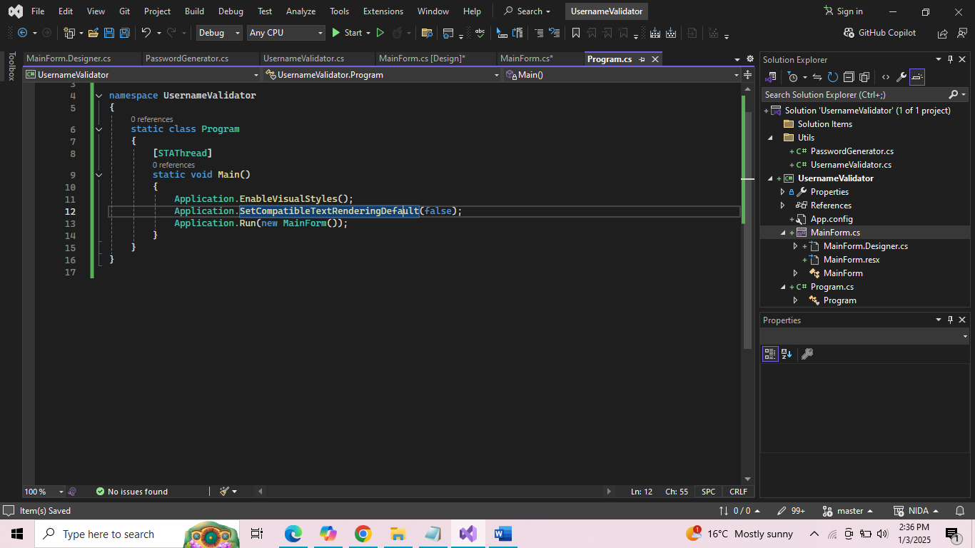

**MainForm.cs**

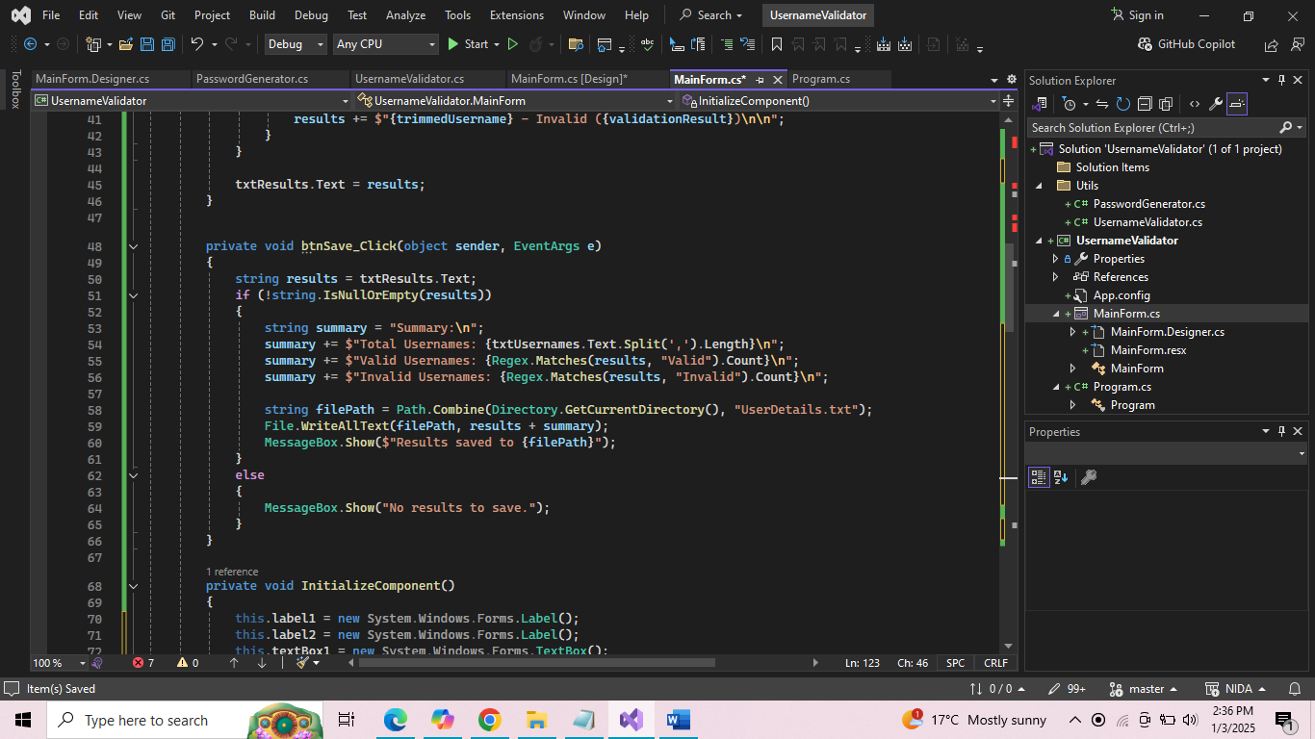

**MainForm_Designer.cs**

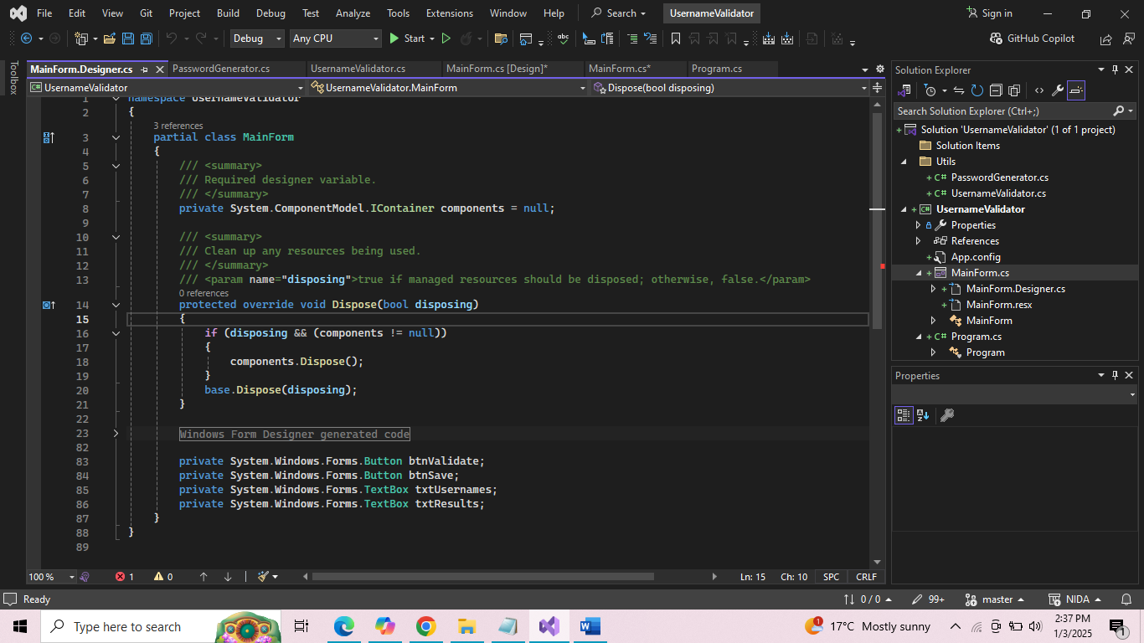

**UserNameValidator.cs**

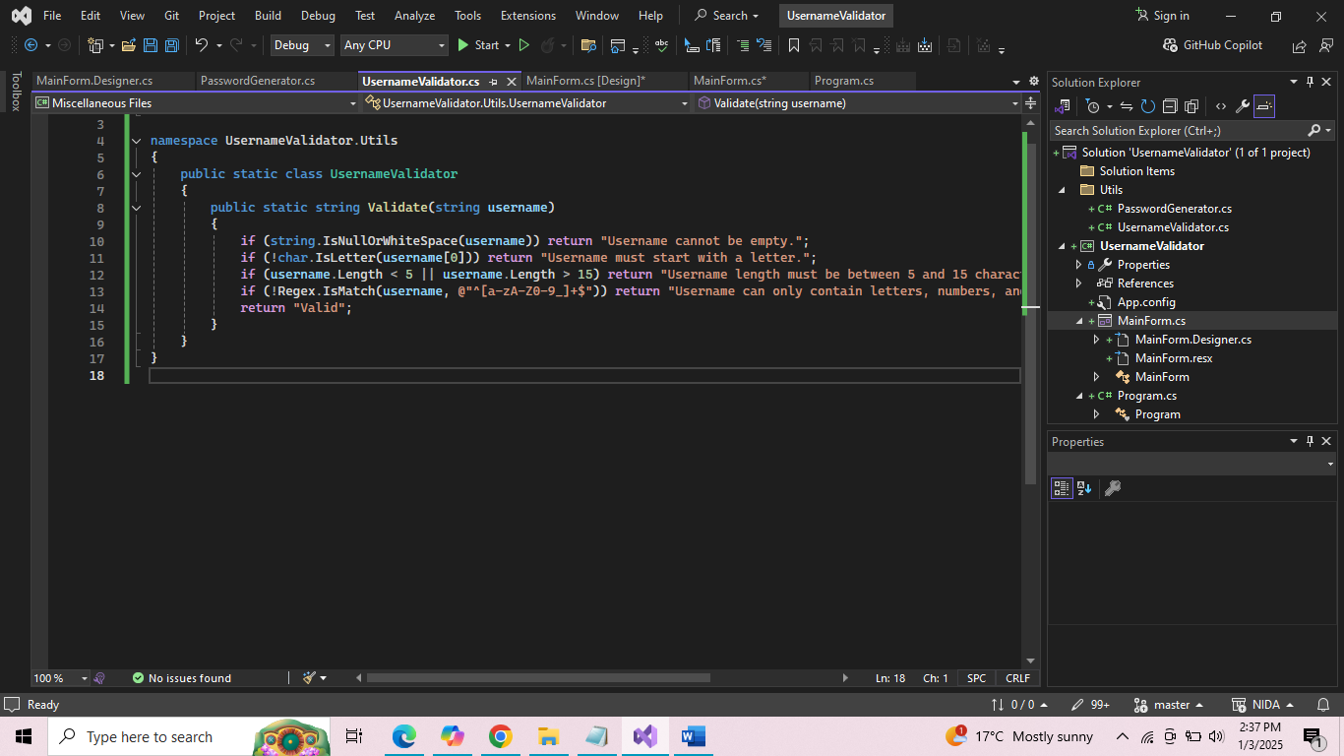

**PasswordGenerator.cs**

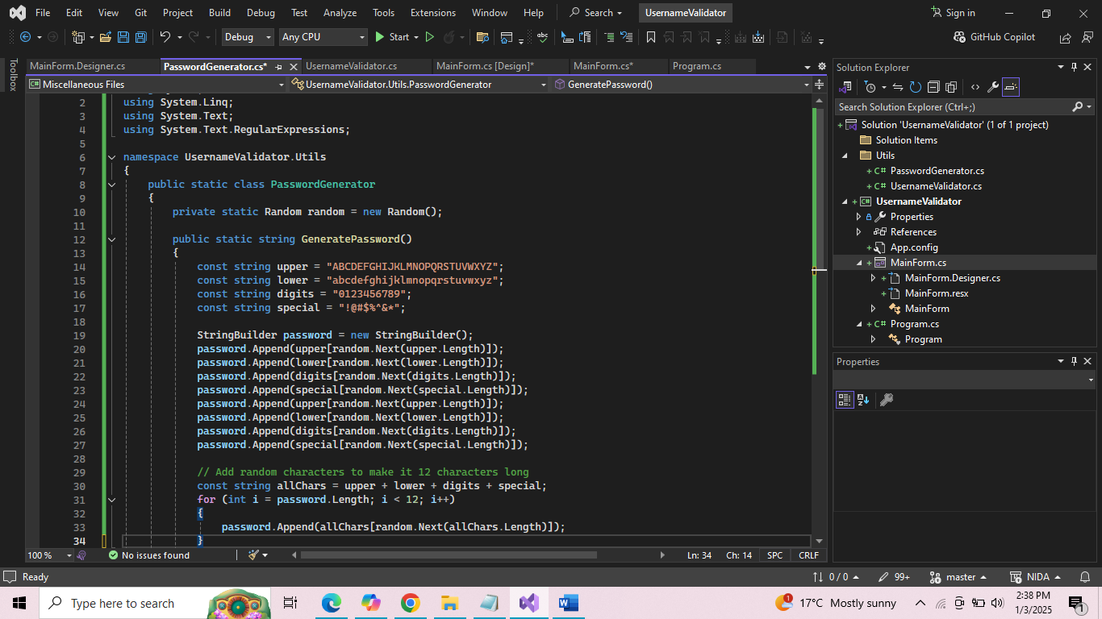

**Output:**

